### Saving Money with a Coupon Box

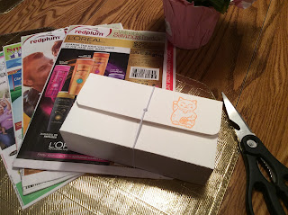

A Coupon Box with a Rubber Band Closure

A coupon box is an excellent way to store coupons for saving money at the grocery store. This box is made out of 140 lb. cold press watercolor paper. The watercolor paper makes the box very sturdy. I also designed the box to have two bottom pieces so that the coupon box would sit firmly on a surface instead of falling over with the weight of the coupons inside.When making the coupon box, thread a large rubber band or elastic thread through the hole in the top of the box and tie as shown in the photo below.

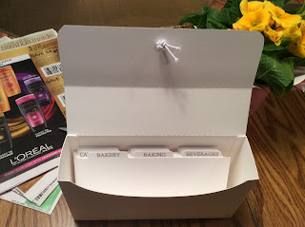

A Look Inside the Coupon Box

I have included eighteen dividers to separate the coupons into different categories. These dividers were cut from card stock.

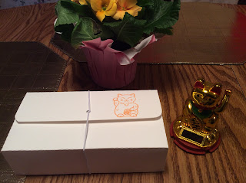

The gold cat is a good luck charm and it is going to bring you lots of money.

Happy Couponing!